Name-Leela jayashree A

Trainer name-Harshee pitroda

Course name- Python and ML

Date-30/5/22

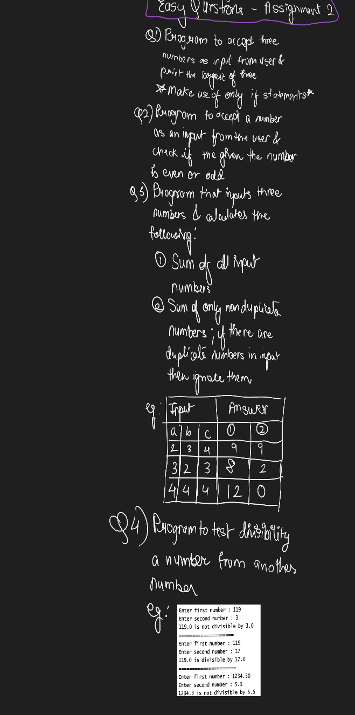

Q1) n1=int(input('enter first number:'))

n2=int(input('enter second number:'))

n3=int(input('enter third number:'))

if (n1>n2) and (n1>n3):

print('n1 is the largest number')

if (n2>n3) and (n2>n1):

print('n2 is the largest number')

if (n3>n1) and (n3>n2):

print('n3 is the largest number')

print('end of the program')

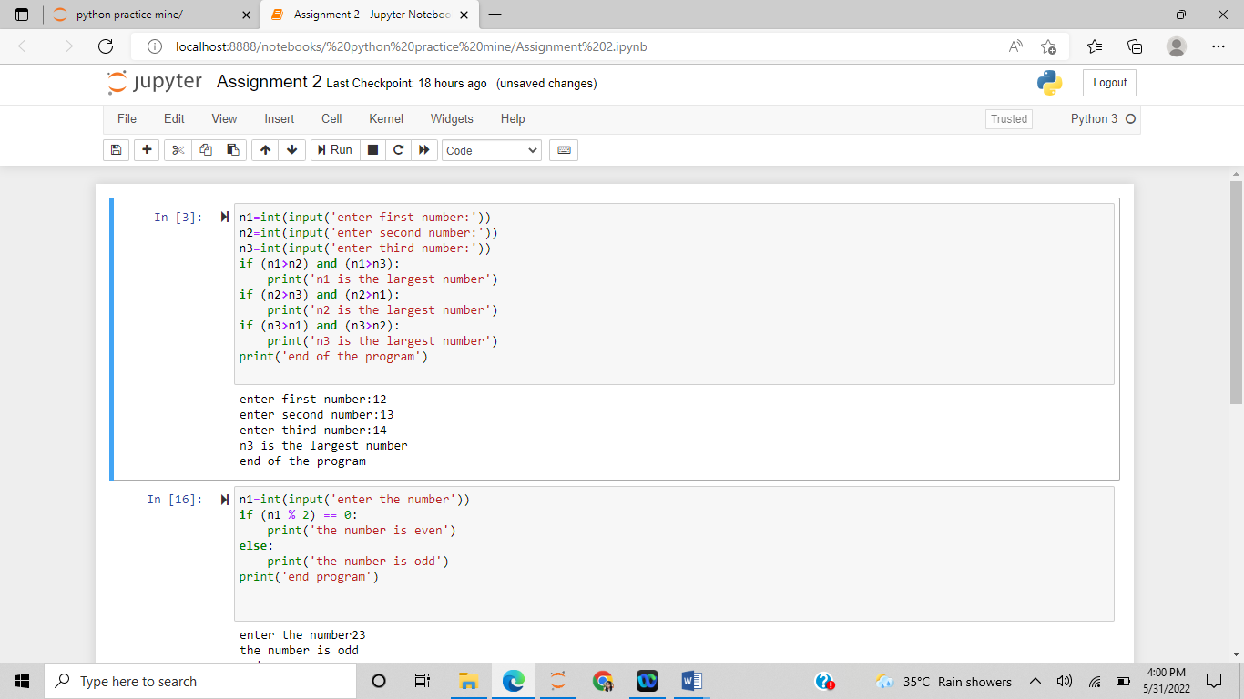

Q2) n1=int(input('enter the number'))

if (n1 % 2) == 0:

print('the number is even')

else:

print('the number is odd')

print('end program')

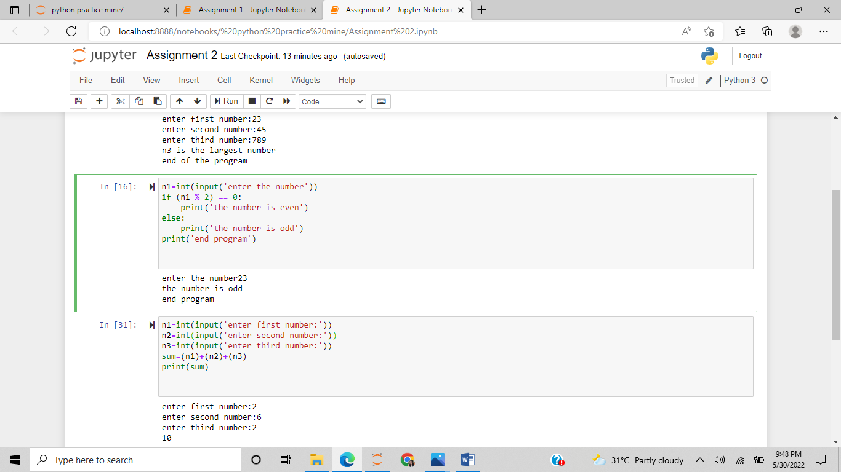

Q4 n1=int(input('enter first number:'))

n2=int(input('enter second number:'))

if n1%n2==0:

print('{}.0 is divisible by {}.0' .format(n1,n2))

else:

print('{}.0 is not divisible by {}.0' .format(n1,n2))

